AML TRANSACTION & FRAUD ANALYSIS DASHBOARD

MONISRI L
E25FA028
B.COM FINTECH AND AI 2nd YEAR

1. Introduction
Anti-Money Laundering (AML) and fraud detection are important activities in the banking and financial sector. Banks and financial institutions need to carefully examine transactions to find unusual activities and possible financial risks.
For this project, I created an AML Transaction and Fraud Analysis Dashboard using Microsoft Power BI. The main aim is to study financial transactions, compare fraud-related records and understand different alert patterns.
I used charts, KPI cards and filters to present the transaction details in an understandable format. The dashboard helps to examine transaction activity over time, compare transaction values and understand different fraud-status categories.
This project also helped me learn how Power BI can be used to present financial data and support the early identification of transactions that may need further checking.
2. Objectives
The major objectives of this project are:
- To study financial transaction details using Power BI.
- To calculate important transaction-related values.
- To examine transaction activity at different time periods.
- To compare transactions based on their fraud status.
- To study changes in fraudulent transaction records.
- To compare the values of different transaction categories.
- To understand the number of alerts under each alert type.
- To create an easy-to-use interactive dashboard.
- To present financial information through different charts.
- To understand how data analysis can help in identifying possible fraud risks.

3. Dataset Description
For this project, I used an AML transaction and fraud-related dataset. It contains information that helps to study financial activities and compare different transaction categories.
The important data fields used in the dashboard are:
- Timestamp: Shows the date and time connected with each transaction. It helps to study transaction activity over time.
- Fraud Status: Shows the classification given to a transaction. It helps to compare different transaction groups.
- Transaction Value: Represents the money involved in a transaction. It is useful for comparing financial values.
- Alert Type: Shows the different types of alerts available in the dataset. It helps to study alert patterns.
These fields are useful for understanding transaction behaviour and examining records that may need additional attention.
4. Data Preparation
Before creating the dashboard, the dataset needs to be checked and prepared properly. This helps to make the analysis more accurate.
The following steps are considered during data preparation:
- Importing Data: Loaded the transaction dataset into Power BI Desktop.
- Column Checking: Examined the column names to understand the available information.
- Data Type Checking: Checked whether numerical, text and date fields had suitable data types.
- Timestamp Checking: Checked the date and time column for analysing transaction trends.
- Value Checking: Ensured that transaction values were suitable for numerical calculations.
- Fraud Status Checking: Examined the fraud categories used in the dataset.
- Alert Type Checking: Reviewed the different alert categories.
- Missing Value Checking: Checked important columns for empty or missing information.
- Measure Creation: Prepared DAX calculations for displaying transaction details in the dashboard.
These steps provide a proper base for creating charts and calculating important values.
5. DAX Measures Used
DAX stands for Data Analysis Expressions. It is used in Power BI to create calculations and display important information from the dataset.
The following measures are suitable for this AML project.
5.1 Total Transaction Count
Total Transaction Count =
COUNTROWS('TransactionData')
This formula counts the total number of transaction records available in the dataset.
5.2 Total Transaction Value
Total Transaction Value =
SUM('TransactionData'[TransactionValue])
This measure adds the transaction amounts and displays the total financial value.
5.3 Fraudulent Transaction Count
Fraudulent Transaction Count =
CALCULATE(
COUNTROWS('TransactionData'),
'TransactionData'[FraudStatus] = "Fraud"
)
This calculation counts the transactions that are marked as Fraud in the fraud-status column.
5.4 Fraudulent Transaction Value
Fraudulent Transaction Value =
CALCULATE(
SUM('TransactionData'[TransactionValue]),
'TransactionData'[FraudStatus] = "Fraud"
)
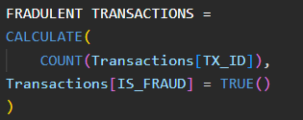
This measure calculates the total monetary value of transactions classified as fraudulent.
6. Visualisations Used in the Dashboard
I selected different charts to present the transaction information clearly. Each chart helps to understand a particular part of the dataset.
6.1 Transaction Volume Across Timestamp
I used a Line Chart to display how transaction activity changes over time.
The timestamp is used to show the time period, and the transaction count is used to measure the activity.
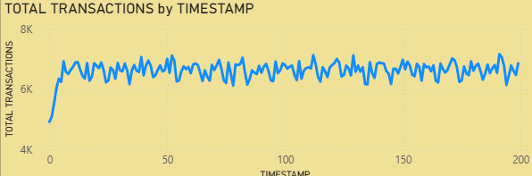
This chart helps to identify periods when transaction activity increases or decreases. Any unusual changes can be examined further.
Purpose: To understand transaction trends over time.
6.2 Transaction Distribution by Fraud Status
I used a Donut Chart to show how transactions are divided among the available fraud-status categories.
It helps users compare the share of each category and understand how the transaction records are distributed.
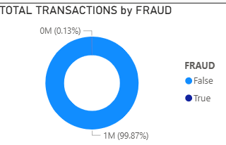
Purpose: To compare the different fraud-status groups.
6.3 Fraudulent Transaction Volume Across Timestamp
I created another Line Chart to study the number of transactions marked as fraudulent over different time periods.
It helps to observe whether fraud-labelled transaction records increase or decrease during a particular period.
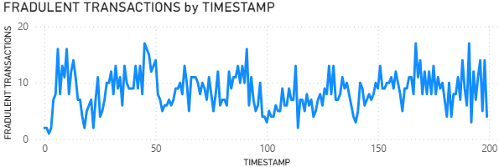
Purpose: To monitor changes in fraud-labelled transactions over time.
6.4 Alerts by Alert Type
I used a Clustered Bar Chart to compare the number of alerts under different alert categories.
This chart makes it easier to identify which alert types have more records and which have fewer records.
Purpose: To compare alert categories and understand their distribution.
6.5 Total Transaction Value by Fraud Status
I created a Clustered Column Chart to compare the total monetary value of transactions under different fraud-status categories.
This chart provides information about the financial value associated with each category.
It also helps users compare transaction amounts instead of looking only at the number of records.
Purpose: To study transaction values across fraud-status groups.
7. KPI Cards
KPI cards are used to display important numerical information in a simple format.
For this dashboard, suitable KPI indicators include:
- Total Transaction Count: Shows how many transaction records are available.
- Total Transaction Value: Displays the combined value of transactions.
- Fraudulent Transaction Count: Shows the number of fraud-labelled records.
- Fraudulent Transaction Value: Displays the total value of fraud-labelled transactions.
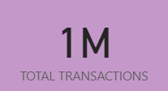 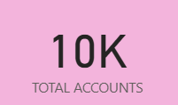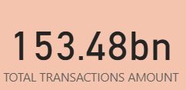 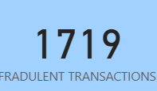
These cards help users understand the main transaction details quickly.
8. Slicers and Filtering
I used slicers to make the dashboard easier to explore.
The visible Fraud Status slicer allows users to select a particular transaction category.
By choosing a required value, users can examine the related information in the dashboard, depending on the visual interactions.
Slicers help users focus on selected information without changing the original dataset.
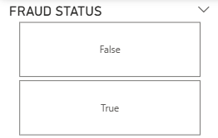 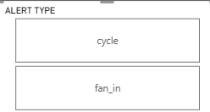
9. Dashboard Interactivity
The dashboard combines different visual elements to provide a better understanding of financial transactions.
The main interactive components are:
- KPI cards for displaying important figures.
- Line charts for studying transaction activity over time.
- Donut chart for comparing fraud-status categories.
- Bar chart for examining alert types.
- Column chart for comparing transaction values.
- Slicers for selecting specific categories.
All these elements provide different views of the same transaction data and make the report easier to explore.
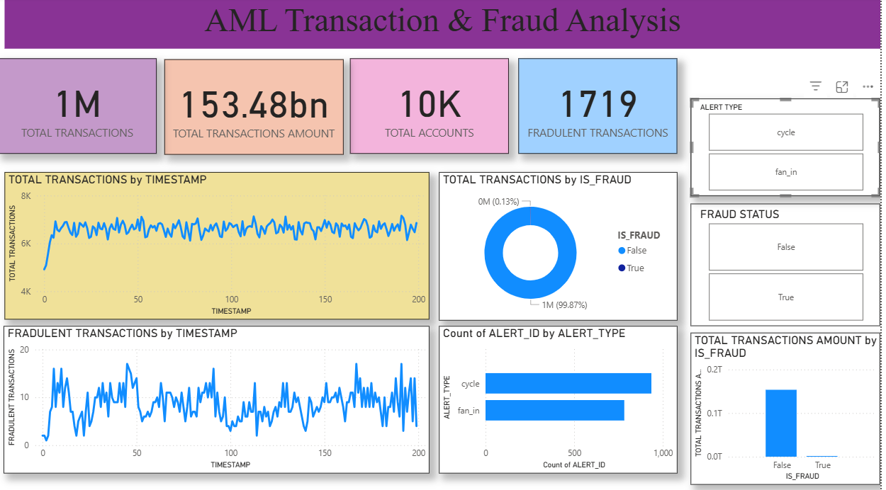
10. Analysis and Key Findings
The dashboard helps to examine the following areas:
1. Transaction Trend Analysis
The line chart helps to understand how transaction activity changes over time.
2. Fraud Status Comparison
The donut chart provides a clear comparison of the transaction categories based on fraud status.
3. Fraud-Labelled Transaction Trends
The second line chart helps to study changes in transactions classified as fraudulent.
4. Alert Category Analysis
The bar chart helps to compare the number of alerts in different categories.
5. Financial Value Comparison
The column chart helps to understand the monetary value of transactions under different fraud-status groups.
6. Overall Transaction Information
KPI cards provide a quick view of the main transaction-related figures.
7. Interactive Data Analysis
Slicers allow users to select the required fraud-status category and explore the related information.
8. Importance of Further Checking
The dashboard can highlight unusual patterns, but additional investigation is needed before confirming any transaction as fraudulent or related to money laundering.
11. Importance of the Dashboard
The AML dashboard is useful for understanding financial transaction activities in one place.
Its main benefits are:
- Makes large transaction data easier to understand.
- Helps compare different fraud-status categories.
- Displays important transaction values.
- Provides information about alert patterns.
- Helps identify unusual changes that may need attention.
- Saves time when reviewing transaction information.
- Supports preliminary financial risk analysis.

12. Conclusion
Through this project, I gained practical knowledge of creating an AML Transaction and Fraud Analysis Dashboard using Microsoft Power BI.
I learned how to use DAX measures, KPI cards, line charts, donut charts, bar charts and column charts to present financial transaction information.
The dashboard helped me understand transaction trends, fraud-status comparisons, alert categories and transaction values. I also learned how interactive filters can make data analysis easier.
Overall, this project improved my understanding of financial data analysis and the role of technology in the banking sector. It also showed me how Power BI can help present transaction information clearly and support the identification of activities that require further investigation.

